IES Consulting – Your internship abroad!
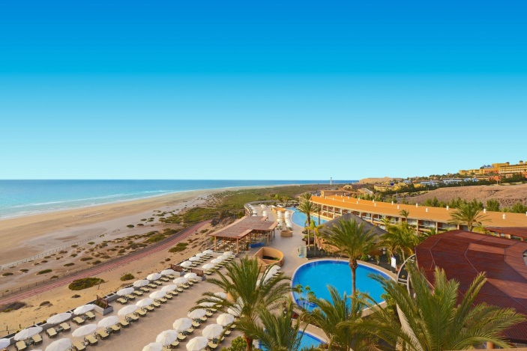
Public Relations in Tenerife
WHERE? Tenerife, Spain
WHEN? Position available all year
DURATION: 3 months
HOW MANY HOURS? Full-time, 40h/week
Luxury hotel located in the south of Tenerife, awarded for its excellent service. They have a fascinating surroundings environment and high quality accomodations. They include services such as Spa, Restaurants, Events, Golf, Bars, Beach Club. Here you will have the opportunity to contribute with your academic experience bringing knowledge, enthusiasm and excelent service.
Before you start recruitment process, please check with your school if they would accept UNIVERSITY AGREEMENT which needs to be signed at the end of recruitment process.

The tasks:
Welcome guests and give them further information about the hotel. Answer all kind of questions about the Canary Islands, various excursions, events and restaurants. Rent cars and make reservations. Handle the complaints of the guests. Use the reception programs “CTM” and “Prestige” correctly. Check in and check out clients, prepare bills and take the payments. Prepare the information papers for the arrivals of the following day. Allocate rooms. International e-mail and phone correspondence. Check and compare the reservations and hotel vouchers. Assistance to the manager. All of these tasks will be done in different languages.
We are looking for:
- Studies: Philology, Communication, Public Relations, Tourism
- Languages: HIGH ENGLISH + BASIC SPANISH
We offer:
- Remuneration: 200€/month + meals + accommodation for the first 2 weeks
- Interesting tasks, international and pleasant work environment
APPLY NOW! Please send us your CV in English or Spanish to
praktyki@ies-consulting.es with the title Public Relations Tenerife

* Our recruitment process is free. Only if you get accepted and the company confirms your application, we will require an administration fee. All our internships provide salary, so we guarantee that costs of the service will pay off.

